Introduction to Scrum Master  - Definition of Scrum Master  - Difference between Scrum Master and Project Manager  - Role of a Scrum Master in Agile teams  - Responsibilities of a Scrum Master  - Skills required for a Scrum Master  - Career scope and opportunities  Agile Fundamentals  - Definition of Agile  - Agile Manifesto and Principles  - Difference between Waterfall and Agile  - Overview of Agile frameworks  Scrum Framework Deep Dive  - What is Scrum  - Scrum pillars (Transparency, Inspection, Adaptation)  - Scrum values  - Scrum roles overview  - Scrum lifecycle | Scrum Roles & Responsibilities  - Scrum Master role in detail  - Product Owner role overview  - Development Team responsibilities  - Collaboration between roles  - Servant leadership concept  Scrum Ceremonies  - Sprint Planning  - Daily Scrum (Stand-up)  - Sprint Review  - Sprint Retrospective  - Timeboxing and best practices  Sprint Planning and Execution  - Sprint goal definition  - Sprint backlog creation  - Capacity planning  - Story point estimation  - Planning Poker technique | User Stories & Backlog Understanding  - What is a user Story  - User Story Format  - Acceptance Criteria  - INVEST Principle  - Backlog Refinement Basics  Estimation Techniques  - Story points vs hours  - Planning Poker  - T-shirt sizing  - Affinity estimation  Facilitation Skills  - Effective meeting facilitation  - Handling conflicts in teams  - Encouraging team participation  - Decision-making techniques | Scrum Master Training Program     : 8555093821   : smyourbusinessanalyst25@gmail.com  : careershiftit.com
Scrum Master as a Coach  - Agile coaching fundamentals  - Mentoring vs Coaching  - Guiding teams towards self-organization  - Building high-performing teams  Impediment Management  - Identifying impediments  - Removing blockers  - Escalation techniques  - Continuous improvement practices  Agile Metrics and Reporting  - Velocity  - Burndown chart  - Burnup chart  - Cycle time & lead time | Agile Tools (JIRA Overview)  - Introduction to Jira  - Scrum boards  - Creating and managing sprints  - Tracking team progress | 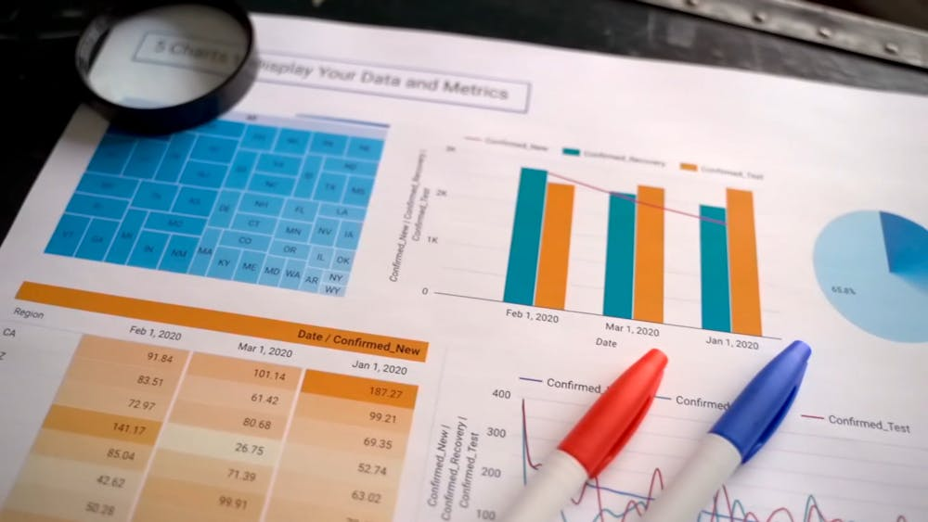 | Scaling Agile (Introduction)  - What is Scaling Agile  - Overview of SAFe  - Scrum of Scrums  - Large team coordination  Risk and Issue Management  - Identifying risks in Agile  - Risk mitigation strategies  - Issue tracking  - Dependency management  Change Management in Agile  - Handling changing requirements  - Managing scope changes  - Adapting to business needs  - Agile mindset for change  Communication & Stakeholder Management  - Working with stakeholders  - Communication strategies  - Reporting progress  - Managing expectations
 |  | Advanced Jira usage  - Reports and dashboards  - Managing workflows  - Backlog grooming in Jira  - Real-time tracking

Agile Mindset & Culture  - Agile culture in organizations  - Continuous improvement mindset  - Team collaboration techniques  - Psychological safety  Real-Time Scrum Scenarios  - Handling difficult team members  - Managing sprint failures  - Resolving team conflicts  - Retrospective simulations | Resume & Interview Preparation  - Scrum Master resume building  - Common interview questions  - Scenario-based answers  - How to explain real-time experience  Mock Interview  - Scrum Master interview simulation  - Scenario-based questions  - Feedback and improvement | 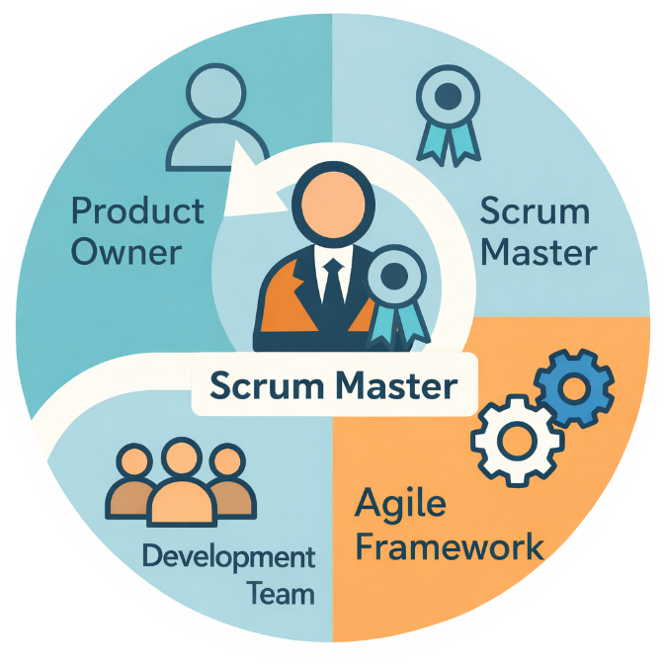 | Tools you will learn  - Jira  - Confluence  - Azure Boards  - Miro  - Slack

