Introduction to Business Analyst  - Definition of Business Analyst  - Difference between Business Analyst and Business Analysis  - Roles & Responsibilities of a BA  - Key Skills Required  - Types of Business Analysts  - Career Scope & Growth Opportunities  Software Development Life Cycle (SDLC)  - SDLC Phases  - Waterfall Methodology  - Agile Methodology  - Difference Between Waterfall & Agile | Real-Time Project Overview  - Competitive & Market Analysis  - Requirement Gathering (SMART Technique)  - Stakeholder Management & Identification  - Requirement Elicitation Techniques  - Requirement Analysis  Documentation Mastery  - BRD (Business Requirement Document)  - FRD (Functional Requirements Document)  - SRS (Software Requirement Specification)  - Functional & Non-Functional Requirements  - Difference between FRD & SRS | User Stories & Acceptance Criteria  - Writing Effective User Stories  - INVEST Criteria  - Real-Time Scenario Practice  - Acceptance Criteria Writing  Prototyping & Wireframing  - Prototypes – Definition & Purpose  - Wireframes & Mock-ups  - Role of BA in UI/UX Collaboration  UAT & Production Validation  - User Acceptance Testing (UAT)  - Production Deployment Overview  - BA Role During UAT | Business Analyst Training Program     : 8555093821   : smyourbusinessanalyst25@gmail.com  : careershiftit.com
Prioritization Techniques  - Moscow Method  - Kano Analysis  - Ranking Method  Risk & Change Management  - Risk Management  - Change Requests  - Statement of Work (SOW)  - Scope Creep  Gap Analysis  - As-Is & To-Be Analysis  - Identifying Process Improvements  Functional Testing & Validation  - Writing Functional Test Cases  - Requirement Validation | Agile Concepts Covered:  - Product Backlog & Sprint Backlog  - Epics, Features, User Stories, Tasks, Bugs  - Story Points & Planning Poker  - Velocity  - Burndown & Burnup Charts  - Gantt Chart  - Spillover & Bug Triage  - Testing Environments | 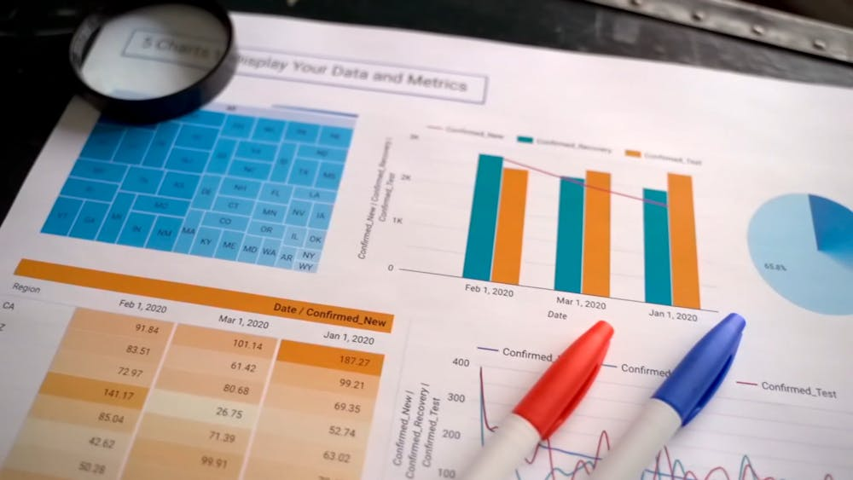 | Tools Covered:  - Jira & Confluence – Agile project management & documentation  - MS Visio – Process flow & system diagrams  - Balsamiq – Wireframing & UI mockups  - MySQL – Database querying & data handling  - Power BI – Data visualization & dashboards  - Microsoft Excel – Data analysis & reporting
 |  | Domain Expertise Included:  - Healthcare – Insurance workflows, patient data & compliance basics  - Banking – Loans, payments, credit systems & financial processes

UML & Process Modelling  - UML Diagrams  - Swimlane Diagrams  - BPMN  Use Case Modelling  - Textual Use Cases  - Diagrammatic Use Cases  Technical Skills Training:  - SQL  - Power BI | Analysis & Strategic Techniques  - Root Cause Analysis (RCA)  - SWOT Analysis  - MOM (Minutes of Meeting)  Traceability & Responsibility Matrix  - RTM  - RACI Matrix  Confluence & Documentation Tools  - Confluence for Documentation  - Draw.io for Mockups & Diagrams | Real-Time Project Scenarios  - Practical case Studies  - End-to-End BA Role Simulation  - Hands-on Scenario Practice  Resume & interview Preparation  - Professional CV Preparation  - Real-Time Project Experience Inclusion  - Sample interview Questions  - Mock Interviews  - Candidate Performance Review | Data & Performance Metrics  - Data Mapping  - KPIs (Key Performance Indicators)  Agile Frameworks & Scrum  - Scrum Framework  - SAFe  - Kanban  - Scrum Roles & Ceremonies  - Sprint & Sprint Duration  - Definition of Ready (DoR) & Definition of Done (DoD)

